Technology enabled learning – Activity plan – Gurumurthy Kasinathan

Name Gurumurthy Kasinathan
Grade 8
Course Geography

Lesson summary
The chapter discusses how the concept of longitude is used to understand time zones.

Lesson objectives
- Purpose of having longitudes
- Idea of time zones from longitudes (why do we need time zones?)

Resource technology – teacher
- Interactive whiteboard OR Laptop and projector
- Video on time zones (OER)
Laptop or desktop computer on which following Free and Open Source Software (FOSS) applications are installed
- Marble Free and Open Source Software (Desktop globe)
- Text editing software (LibreOffice Writer Free and Open Source Software)
- Screen casting software (RecordMyDesktop Free and Open Source Software)
Marble is a mapping software focusing on physical geography. You can open maps of the earth (and also of some other planets in our Solar System, Moon etc) and see the physical features of different regions of the earth. Since it is a digital map, you can zoom in/out, move the earth in different directions etc.

Resource technology – student
Laptop or desktop computer on which the above mentioned Free and Open Source Software (FOSS) applications are installed

Intended curricular learning outcomes
- Students will understand the concept of longitudes and time zones

Instructional activities

Teacher (20 minutes)
- Demonstration of the Marble software application
- The Marble educational software can be used to demonstrate Longitudes. By increasing the scale by moving the 'navigation slider',we can increase the map size.
- Demonstrate Longitudes on the Marble atlas. Move the earth from west to east to simulate the rotation of the earth.
- Explain and discuss
- Explain why different time zones are needed
- Longitudes are not lines but curves
- Longitudes are imaginary curves, created for enabling tracking of time across the earth
- Demonstrate that Longitudes are not 'parallel' to one another, but meet at the poles.
- The Marble educational software can be used to demonstrate Longitudes. By increasing the scale by moving the 'navigation slider',we can increase the map size. We can demonstrate that Longitudes are not 'parallel'to one another, but meet at the poles.
- Show the video from https://youtu.be/X1DkiuaFCuA on Time zones
- Discuss the concept of longitudes by moving the globe in Marble from left to right to simulate movement of the earth and the concept of time and time zones

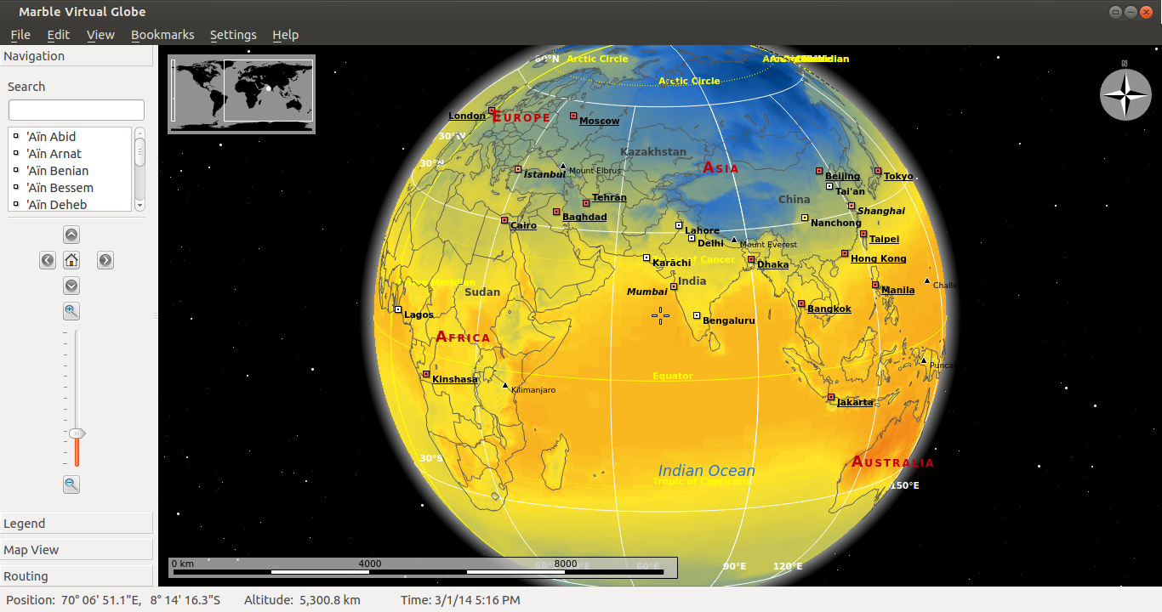
Illustration 1: Marble Desktop Globe software

Student activities (30 minutes)
- Ask students to create a video in their own language, using their own words, using screen casting software ‘RecordMyDesktop’ and use Marble and explain the rotation of the earth and why it causes different time in different locations.
- Student write a short note on the concept of longitude in a text document, and embed screenshot images of Marble
- Mobile phones can have software application to record the latitude and longitude information of a place. For eg OSM Tracker on a Android phone can record the 'lat long' information about a place, and even record a track, such as a road. Students should try recording using this on a cell phone. They can also upload this information on a digital map on the Internet such as the openstreetmap (http://openstreetmap.org).

Learner assessment
Ask the following questions (one by one) and have a discussion in the class
- If the earth was not rotating on its axis,would there be any need for time zones and longitudes?
- If the earth was not revolving around the sun, would there be any need for time zones and longitudes?
- While the equator (zero degree latitude) is a 'circle', the zero degree longitude (prime meredian passing through Greenwich) is a half circle. Why is this?
- The reason why longitudes help us to understand the movement of day and night (passage of time in our 24 hour clock) is because the earth rotates around the sun in an east-west direction. Is this statement correct? What if the earth were to rotate around a east-west axis (that is from north to south or south to north) instead of a north-south axis? Would longitudes as they are defined now, be of any help?

OER referred to
https://en.wikipedia.org/wiki/History_of_longitude
https://en.wikipedia.org/wiki/longitude
http://karnatakaeducation.org.in/KOER/en/index.php/The_Earth-Our_Living_Planet
http://troer.telangana.gov.in/OER/index.php/ICT_teacher_handbook/The_globe_on_your_table_with_Marble

